**Reservation Systems**

Project Code

import java.util.*;

class Project

{

String userId[] = {"Pavan","Shreya","Deepika","Rameettha","Vignesh","Shiva"};

String code[] = {"pa15","sh20","de06","ra26","vi28","sh19"};

String cities[]={"Bangalore","Chennai","Mysore","Mumbai","Delhi"};

String accId="";String acccd="";

int nop=0;boolean bole;

String stiming =" ";String dtiming =" ";

String name[]= new String[6];int month=0; int year=0;String SS="";String DS="";String cl="";

String gender[]=new String[6];int ppn;int i;

int age[]=new int[6];int mop=0;String cn = "";long pn=0;String id="";int choice=0;int Child=0;int Adult=0;

String berth[]=new String[6];String tc="";double Fare=0.0;double bfare=0.0;int SC=0;int date=0;int cvv=0;

public static void main ()//calling all methods

{

//System.out.println("\nEntering main()");

klk:

for(;;)

{

Project obj = new Project();

System.out.println(" Welcome to PVRDSS Booking System \n");

System.out.print("1.Train Ticket Reservation\n2.Movie Ticket Reservation\nEnter your choice : ");

Scanner scart = new Scanner(System.in);

int choice = scart.nextInt();

if(choice ==1)

{

obj.login();

obj.selection();

obj.display();

}

else if(choice ==2)

{

obj.login();

obj.movie();

}

else

{System.out.println("Wrong choice.Plz try again");System.out.println();continue klk;}

break;

}

}

public void login()//for login

{

LOOP:for(;;)

{

System.out.println();

Scanner scan = new Scanner(System.in);

System.out.print("Enter user ID: ");

accId=scan.next().trim();

System.out.print("\nEnter user password: ");

acccd=scan.next().trim();

System.out.println();

int count = 0,i=0;

for( i = 0;i<=5;i++)

{

if (accId.equals(userId[i]) && acccd.equals(code[i]))

{

System.out.println("Welcome to ticket reservation ,"+userId[i]);

break;

}

count++;

}

if(count==6)

{

System.out.println("Wrong username or password.Plz try again");

continue LOOP;

}

if(i>4)

{

i-=1;

if(accId.equals(userId[i]) && acccd.equals(code[i]))

{

selection();

}

}

break;

}

}

public void selection()//choose other details

{

System.out.println();

System.out.println("_______________Welcome to MAKE MERA TRIP_______________");

System.out.println();

Scanner sc = new Scanner(System.in);

Scanner sc9 = new Scanner(System.in);

Outer :

for(;;)

{

System.out.println("START STATION");

for(i=0;i<5;i++)

{

System.out.println((i+1)+"."+cities[i]);

}

System.out.println("-------------");

System.out.print("Enter Start Station: ");

SS= sc.nextLine();

System.out.println();

System.out.println("DESTINATION STATION");

for(i=0;i<5;i++)

{

System.out.println((i+1)+"."+cities[i]);

}

System.out.println("-------------");

System.out.print("Enter Destination Station: ");

DS= sc9.nextLine();

System.out.println("_______________________________________________________________________");

System.out.println();

if(SS.equalsIgnoreCase(DS))

{

System.out.println("Invalid Choice!!!.Please enter again");

continue Outer;

}

System.out.println("Please Enter the date within 3 months from today ");

System.out.print("Date of journey :");date =sc.nextInt();

System.out.print("Month of journey(Eg:1 for january) :");month =sc.nextInt();

System.out.print("Year of journey :"); year =sc.nextInt();

System.out.println();

System.out.println("Sl.no\t\tTrains available\t\tArrival\t\t Deapature\tFare(Per Person)");

Scanner scan=new Scanner (System.in);

if (SS.equalsIgnoreCase("Bangalore")&& DS.equalsIgnoreCase("Chennai"))//to print respective trains for places

{

System.out.println("1. \t\tShatabdi Exp \t\t6:00 \t\t11:00 \t500");

System.out.println("2. \t\tLalbagh Exp \t\t6:30 \t\t00:15 \t600");

System.out.println();

System.out.println("Enter train of your choice(name):");

tc= scan.nextLine();

if(tc.equals("Shatabdi Exp"))

{bfare=500;stiming="6:00";dtiming="11:00";}//to store basic fare

else if(tc.equals("Lalbagh Exp"))

{bfare=600;stiming="6:30";dtiming="00:15";}

}

else if(SS.equalsIgnoreCase("Chennai")&& DS.equalsIgnoreCase("Bangalore"))

{

System.out.println("1. \t\tShatabdi Exp \t\t6:00 \t\t11:00 \t500");

System.out.println("2. \t\tLalbagh Exp \t\t6:30 \t\t00:15 \t600");

System.out.println();

System.out.println("Enter train of your choice(name):");

tc= scan.nextLine();

if(tc.equals("Shatabdi Exp"))

{bfare=500;stiming="6:00";dtiming="11:00";}

else if(tc.equals("Lalbagh Exp"))

{bfare=600;stiming="6:30";dtiming="00:15";}

}

else if(SS.equalsIgnoreCase("Bangalore")&& DS.equalsIgnoreCase("Mysore"))

{

System.out.println("1. \t\tKaveri Exp \t\t6:50 \t\t04:00 \t400");

System.out.println("2. \t\tTippu Exp \t\t15:00 \t\t18:30 \t550");System.out.println();

System.out.println("Enter train of your choice(name):");

tc= scan.nextLine();

if(tc.equals("Kaveri Exp"))

{bfare=400;stiming="6:50";dtiming="04:00";}

else if(tc.equals("Tippu Exp"))

{bfare=550;stiming="15:00";dtiming="18:30";}

}

else if(SS.equalsIgnoreCase("Mysore")&& DS.equalsIgnoreCase("Bangalore"))

{

System.out.println("1. \t\tKaveri Exp \t\t6:50 \t\t04:00 \t400");

System.out.println("2. \t\tTippu Exp \t\t15:00 \t\t18:30 \t550");System.out.println();

System.out.println("Enter train of your choice(name):");

tc= scan.nextLine();

if(tc.equals("Kaveri Exp"))

{bfare=400;stiming="6:50";dtiming="04:00";}

else if(tc.equals("Tippu Exp"))

{bfare=550;stiming="15:00";dtiming="18:30";}

}

else if(SS.equalsIgnoreCase("Bangalore")&& DS.equalsIgnoreCase("Mumbai"))

{

System.out.println("1. \t\tUdhyan Exp \t\t20:45 \t\t19:17 \t700");

System.out.println("2. \t\tGaribrath Exp \t\t16:45 \t\t14:30 \t650");System.out.println();

System.out.println("Enter train of your choice(name):");

tc= scan.nextLine();

if(tc.equals("Udhyan Exp"))

{bfare=700;stiming="20:45";dtiming="19:17";}

else if(tc.equals("Garibrath Exp"))

{bfare=650;stiming="16:45";dtiming="14:30";}

}

else if(SS.equalsIgnoreCase("Mumbai")&& DS.equalsIgnoreCase("Bangalore"))

{

System.out.println("1. \t\tUdhyan Exp \t\t20:45 \t\t19:17 \t700");

System.out.println("2. \t\tGaribrath Exp \t\t16:45 \t\t14:30 \t650");System.out.println();

System.out.println("Enter train of your choice(name):");

tc= scan.nextLine();

if(tc.equals("Udhyan Exp"))

{bfare=700;stiming="20:45";dtiming="19:17";}

else if(tc.equals("Garibrath Exp"))

{bfare=650;stiming="16:45";dtiming="14:30";}

}

else if(SS.equalsIgnoreCase("Bangalore")&& DS.equalsIgnoreCase("Delhi"))

{

System.out.println("1. \t\tRajdhani Exp \t\t 20:00 \t\t18:54 \t900");

System.out.println("2. \t\tMillennium Exp \t\t 23:45 \t\t18:17 \t650");System.out.println();

System.out.println("Enter train of your choice(name):");

tc= scan.nextLine();

if(tc.equals("Rajdhani Exp"))

{bfare=900;stiming="20:00";dtiming="18:54";}

else if(tc.equals("Millenium Exp"))

{bfare=650;stiming="23:45";dtiming="18:17";}

}

else if(SS.equalsIgnoreCase("Delhi")&& DS.equalsIgnoreCase("Bangalore"))

{

System.out.println("1. \t\tRajdhani Exp \t\t 20:00 \t\t18:54 \t900");

System.out.println("2. \t\tMillennium Exp \t\t 23:45 \t\t18:17 \t650");System.out.println();

System.out.println("Enter train of your choice(name):");

tc= scan.nextLine();

if(tc.equals("Rajdhani Exp"))

{bfare=900;stiming="20:00";dtiming="18:54";}

else if(tc.equals("Millenium Exp"))

{bfare=650;stiming="23:45";dtiming="18:17";}

}

else if(SS.equalsIgnoreCase("Chennai")&& DS.equalsIgnoreCase("Mysore"))

{

System.out.println("1. \t\tKaveri Exp \t\t06:50 \t\t21:00 \t300");

System.out.println("2. \t\tMysore Exp \t\t08:20 \t\t23:30 \t550");System.out.println();

System.out.println("Enter train of your choice(name):");

tc= scan.nextLine();

if(tc.equals("Kaveri Exp"))

{bfare=300;stiming="06:50";dtiming="21:00";}

else if(tc.equals("Mysore Exp"))

{bfare=550;stiming="08:20";dtiming="23:30";}

}

else if(SS.equalsIgnoreCase("Mysore")&& DS.equalsIgnoreCase("Chennai"))

{

System.out.println("1. \t\tKaveri Exp \t\t6:50 \t\t 21:00 \t300");

System.out.println("2. \t\tMysore Exp \t\t08:20 \t\t23:30 \t550");System.out.println();

System.out.println("Enter train of your choice(name):");

tc= scan.nextLine();

if(tc.equals("Kaveri Exp"))

{bfare=300;stiming="06:50";dtiming="21:00";}

else if(tc.equals("Mysore Exp"))

{bfare=550;stiming="08:20";dtiming="23:30";}

}

else if(SS.equalsIgnoreCase("Chennai")&& DS.equalsIgnoreCase("Mumbai"))

{

System.out.println("1. \t\tChennai Exp \t\t06:00 \t\t06:50 \t800");

System.out.println("2. \t\tMumbai Exp \t\t13:35 \t\t11:55 \t950");System.out.println();

System.out.println("Enter train of your choice(name):");

tc= scan.nextLine();

if(tc.equals("Chennai Exp"))

{bfare=800;stiming="06:00";dtiming="06:50";}

else if(tc.equals("Mumbai Exp"))

{bfare=950;stiming="13:35";dtiming="11:55";}

}

else if(SS.equalsIgnoreCase("Mumbai")&& DS.equalsIgnoreCase("Chennai"))

{

System.out.println("1. \t\tChennai Exp \t\t06:00 \t\t06:50 \t800");

System.out.println("2. \t\tMumbai Exp \t\t13:35 \t\t11:55 \t950");System.out.println();

System.out.println("Enter train of your choice(name):");

tc= scan.nextLine();

if(tc.equals("Chennai Exp"))

{bfare=800;stiming="06:00";dtiming="06:50";}

else if(tc.equals("Mumbai Exp"))

{bfare=950;stiming="13:35";dtiming="11:55";}

}

else if(SS.equalsIgnoreCase("Chennai")&& DS.equalsIgnoreCase("Delhi"))

{

System.out.println("1. \t\tGrand Trunk Exp \t\t06:20 \t\t19:15 \t900");

System.out.println("2. \t\tRajdhani Exp \t\t10:35 \t\t06:40 \t1000");System.out.println();

System.out.println("Enter train of your choice(name):");

tc= scan.nextLine();

if(tc.equals("Grand Trunk Exp"))

{bfare=900;stiming="06:20";dtiming="19:15";}

else if(tc.equals("Rajdhani Exp"))

{bfare=1000;stiming="10:35";dtiming="06:40";}

}

else if(SS.equalsIgnoreCase("Delhi")&& DS.equalsIgnoreCase("Chennai"))

{

System.out.println("1. \t\tGrand Trunk Exp \t\t06:20 \t\t19:15 \t900");

System.out.println("2. \t\tRajdhani Exp \t\t10:35 \t\t06:40 \t1000");System.out.println();

System.out.println("Enter train of your choice(name):");

tc= scan.nextLine();

if(tc.equals("Grand Trunk Exp"))

{bfare=900;stiming="06:20";dtiming="19:15";}

else if(tc.equals("Rajdhani Exp"))

{bfare=1000;stiming="10:35";dtiming="06:40";}

}

else if(SS.equalsIgnoreCase("Mysore")&& DS.equalsIgnoreCase("Mumbai"))

{

System.out.println("No trains");tc="";break;

}

else if(SS.equalsIgnoreCase("Mumbai")&& DS.equalsIgnoreCase("Mysore"))

{

System.out.println("No trains");tc="";break;

}

else if(SS.equalsIgnoreCase("Mysore")&& DS.equalsIgnoreCase("Delhi"))

{

System.out.println("1. \t\tSwarna Jayanthi \t\t17:10 \t\t20:10 \t900");System.out.println();

System.out.println("Enter train of your choice(name):");

tc= scan.nextLine();

bfare=900;stiming="17:10";dtiming="20:10";

}

else if(SS.equalsIgnoreCase("Delhi")&& DS.equalsIgnoreCase("Mysore"))

{

System.out.println("1. \t\tSwarna Jayanthi \t\t17:10 \t\t20:10 \t900");System.out.println();

System.out.println("Enter train of your choice(name):");

tc= scan.nextLine();

bfare=900;stiming="17:10";dtiming="20:10";

}

else if(SS.equalsIgnoreCase("Mumbai")&& DS.equalsIgnoreCase("Delhi"))

{

System.out.println("1. \t\tDehradun Exp \t\t05:25 \t\t12:05 \t800");

System.out.println("2. \t\tPunjab Mail \t\t17:40 \t\t21:15 \t950");System.out.println();

System.out.println("Enter train of your choice(name):");

tc= scan.nextLine();

if(tc.equals("Dehradun Exp"))

{bfare=800;stiming="05:25";dtiming="12:05";}

else if(tc.equals("Punjab Mail"))

{bfare=950;stiming="17:40";dtiming="21:15";}

}

else if(SS.equalsIgnoreCase("Delhi")&& DS.equalsIgnoreCase("Mumbai"))

{

System.out.println("1. \t\tDehradun Exp \t\t05:25 \t\t12:05 \t800");

System.out.println("2. \t\tPunjab Mail \t\t17:40 \t\t21:15 \t950");System.out.println();

System.out.println("Enter train of your choice(name):");

tc= scan.nextLine();

if(tc.equals("Dehradun Exp"))

{bfare=800;stiming="05:25";dtiming="12:05";}

else if(tc.equals("Punjab Mail"))

{bfare=950;stiming="17:40";dtiming="21:15";}

}

else

{

System.out.println("Invalid Choice");continue Outer;

}

System.out.println();

System.out.println("Class you would like to travel in(SL,CC,1A,2A,3A)");

cl=scan.next();

System.out.println();

System.out.println("NOTE:\n1.Pls Enter your FULL NAME\n2.Enter your gender as 'm' or'f'\n3.Enter your berth as 'u' for upper;'m' for middle; 'l'for lower");

Scanner x = new Scanner(System.in);

Scanner scans = new Scanner(System.in);

LOOP1:

for(;;)

{

System.out.println();

System.out.print("No. of ppl traveling(max 6):");

ppn=scan.nextInt();

System.out.println();

if(ppn>0&&ppn<=6)

{

//System.out.println("Enter Passenger Name:");

for( i=0;i<ppn;i++)//accept passesnger name

{

System.out.println();

System.out.print("Enter Passenger "+(i+1)+" Name :");

name[i] = x.nextLine();

System.out.print("Enter Passenger "+(i+1)+" Age :");

age[i] = x.nextInt();

if (age[i]<=12)

{Child++;}

else if (age[i]>=13 && age[i]<60)

{Adult++;}

else if (age[i]>=60)

{SC++;}

System.out.print("Enter Passenger "+(i+1)+" Gender :");

gender[i] = x.next();

System.out.print("Enter Passenger "+(i+1)+" Berth :");

berth[i] = x.next();//was z instead of x

x.nextLine();//to flush the input buffer

}

}

else

{

System.out.println("Invalid choice.maximum of 6 persons only");System.out.println();continue LOOP1;

}

break;

}

System.out.println();

System.out.print("Your ticket costs:"+(ppn*bfare));

System.out.println();

Scanner z = new Scanner(System.in);

LABEL3:

for(;;)

{

System.out.println("Mode of Payment\n1.Card\n2.Paytm\t(1 or 2)");

mop = z.nextInt();

System.out.println();

switch (mop)

{

case 1:

System.out.print("Card no.: ");

cn=scan.next();

if(cn.length()>16||cn.length()<16)

{System.out.println("Invalid Card no.plz enter again\n");System.out.println();continue LABEL3;}

System.out.print("CVV Number: ");

cvv = scan.nextInt();

Scanner ty = new Scanner(System.in);

System.out.print("Email-Id :");

id=ty.nextLine();

if(cvv >= 100 && cvv <= 999)

{

System.out.println("Transaction Sucessful");

System.out.println("The status of your ticket is sent to your Email.");

System.out.println();

}

else

{

System.out.println("Invalid CVV.");System.out.println();continue LABEL3;

}

break;

case 2:

Scanner fg = new Scanner(System.in);

System.out.print("Mobile Phone no.");

String phn=fg.next();

if(phn.length()<10||phn.length()>10)

{System.out.println("Invalid Mobile Phone number.");System.out.println();continue LABEL3;}

Scanner sd = new Scanner(System.in);

System.out.print("Email-Id");

id=sd.next();

System.out.println();

System.out.println("Transaction Sucessful");

System.out.println("The status of your ticket is sent to your Email.");

System.out.println();

break;

default:

System.out.println("Invalid Choice");System.out.println();continue LABEL3;

}

break;

}

break;

}

}

public void display()

{System.out.println("=========================================Indian Railways=====================================");

System.out.println("_____________________________________________________________________________________________");

System.out.println("Sl no.\t NAME \tAGE\tGENDER\tBERTH");

for (i=0;i<ppn;i++)

{

System.out.println((i+1)+"\t"+name[i]+"\t"+age[i]+"\t"+gender[i]+"\t"+berth[i]);

}

System.out.println("_____________________________________________________________________________________________");

System.out.println("No. of Adults:"+Adult);

System.out.println("No. of Children:"+Child);

System.out.println("No. of Senior Citizen:"+SC);

System.out.println("Total no. of passengers:"+ppn);

System.out.println("_____________________________________________________________________________________________");

System.out.println("> Train Name:"+tc);

System.out.println("> Train Arrival:"+stiming);

System.out.println("> Train Departure:"+dtiming);

int pnr=0;

pnr=(int)((Math.random()*100000)+10012533);

System.out.println("> PNR:"+pnr);

int tkt=0;

tkt=(int)((Math.random()*500)+105);

System.out.println("> Ticket No.:");

for(int i =1;i<=ppn;i++)

{

System.out.println("*"+tkt);

tkt++;

}

System.out.println();

System.out.println("_____________________________________________________________________________________________");

System.out.println("> Date of Journey:"+date+"/"+month+"/"+year);

System.out.println("> Departure Station:"+SS);

System.out.println("> Destination Station:"+DS);

System.out.println("> Class:"+cl);

System.out.println("_____________________________________________________________________________________________");

System.out.println("ppn:"+ppn+"\tbfare:"+bfare);

System.out.println("> Your ticket costs:"+(ppn*bfare));

System.out.println("> The copy of your ticket is sent to your Email.");

System.out.println("THANK YOU FOR CHOOSING PVRDSS BOOKING SYSTEM");

System.out.println("================================Have A Happy Journey=====================================");

}

public void movie()

{

Scanner scan = new Scanner(System.in);

int ch ;int ch1;int ch2;int ch3;

String SC[]={"1.SCREEN one","2.SCREEN two","3.SCREEN three","4.SCREEN four"};

String ST[]={"1.MORNING SHOW - 9:00 TO 11:15","2.MATINEE SHOW - 12:45 TO 3:15","3.EVENING SHOW - 4:15 TO 6:30","4.NIGHT SHOW - 7:30 TO 9:45","5.MIDNIGHT SHOW - 10:30 TO 12:45"};

String t[]={"1.PVR Cinemas","2.Inox","3.Rex Theatre","4.Sholay Theatre"};

System.out.println("_______________Welcome to BOOK MERA SHOW_______________");System.out.println();

System.out.println("CHOOSE A MOVIE FROM THE LIST BELOW");

String mn[]={"1.Doctor Strange","2.The Dictator","3.Wolf of Wall Street","4.The Minions","5.Frozen","6.300:Rise of an Empire","7.The Dark Knight Rises"};

int lmn=7;

LIGGA:

for(;;)

{

for(int i = 0;i<lmn;i++)

{

System.out.println(mn[i]);

}

System.out.print("Enter your choice(Eg:1):");

ch = scan.nextInt();

if(ch>7)

{

System.out.println("Invalid Choice.Plz choose again");System.out.println();

continue LIGGA;

}

break;

}

MIGGA:

for(;;)

{

System.out.println();

System.out.println("CHOOSE A THEATRE FROM THE LIST BELOW");

for(int i = 0;i<4;i++)

{

System.out.println(t[i]);

}

System.out.print("Enter your choice(Eg:1):");

ch1 = scan.nextInt();

if(ch1>4)

{

System.out.println("Invalid choice.Plz choose again");System.out.println();

continue MIGGA;

}

break;

}

KIGGA:

for(;;)

{

System.out.println();

System.out.println("CHOOSE A SCREEN FROM THE LIST BELOW");

for(int i = 0;i<4;i++)

{

System.out.println(SC[i]);

}

System.out.print("Enter your choice(Eg:1):");

ch2 = scan.nextInt();

if(ch2>4)

{

System.out.println("Invalid choice.Plz choose again");System.out.println();

continue KIGGA;

}

break;

}

System.out.println();

System.out.println("CHOOSE A DATE FOR YOUR SHOW");

int da1=0;int mo1=0;int ye1=0;

nigga:for(;;)

{

System.out.print("Enter the Date(Eg:1):");

int da = scan.nextInt();da1=da;

if(da>=1&&da<=31)

{

System.out.print("Enter the Month(Eg:1):");

int mo = scan.nextInt();mo1=mo;

if(mo>=1&&mo<=12)

{

System.out.print("Enter the Year:");

int ye = scan.nextInt();ye1 = ye;

if(ye==2017)

{

System.out.println("DATE CONFIRMED");

}

else

{

System.out.println("WRONG DATE.plz enter again");System.out.println();

continue nigga;

}

}

else

{

System.out.println("WRONG MONTH.plz enter again");System.out.println();

continue nigga;

}

}

else

{

System.out.println("WRONG DAY.plz enter again");System.out.println();

continue nigga;

}

System.out.println();

JIGGA:

for(;;)

{

System.out.println();

System.out.println("CHOOSE A SHOW TIMING FROM THE LIST BELOW");

for(int i = 0;i<5;i++)

{

System.out.println(ST[i]);

}

System.out.print("Enter your Choice(Eg:1):");

ch3 = scan.nextInt();

if((ch3-1)>4)

{

System.out.println("Invalid choice.Plz choose again");System.out.println();

continue JIGGA;

}

break;

}

Scanner f = new Scanner(System.in);

LABELk:

for(;;)

{

System.out.println();

System.out.print("Enter number of tickets required(max 4) : ");

nop = f.nextInt();

if(nop>4||nop<=0)

{

System.out.println("Invalid choice.Plz choose again");System.out.println();

continue LABELk;

}

break;

}

NIGGA:

for(;;)

{

System.out.println();

int x[][]=new int[5][10];

for(int i = 0;i<=4;i++)

{

for(int j = 0;j<=9;j++)

{

x[i][j]=0;

}

}

x[3][7]=1;x[2][1]=1;x[0][7]=1;x[4][6]=1;

System.out.println("---------------THEATRE SEAT SELECTION---------------");

System.out.println("---------------0:EMPTY AND 1:OCCUPIED---------------");

for(int i = 0;i<=4;i++)

{

for(int j = 0;j<=9;j++)

{

System.out.print(x[i][j]+" ");

}

System.out.println();

}

for(int e=1;e<=nop;e++)

{

int z =(int)(Math.ceil(Math.random()*10000));

Scanner scR = new Scanner(System.in);

int r[]=new int[4];int c[]=new int[4];

for(int e1=0;e1<nop;e1++)

{

System.out.println();

System.out.print("Enter your ROW NUMBER: ");

r[e1] = scR.nextInt();

System.out.print("Enter your COLUMN NUMBER:");

c[e1] = scR.nextInt(); System.out.println();

}

for(int e1=0;e1<nop;e1++)

{

if(x[r[e1]-1][c[e1]-1]==0)

{bole = true;}

else

{bole =false ;break;}

}

Scanner z6 = new Scanner(System.in);

if(bole = true)

{

System.out.println("Your seat(s) is/are AVAILABLE");

System.out.println();

System.out.println("Cost of tickets : "+(nop*500));

LABEL2:

for(;;)

{

System.out.println();

System.out.println("Mode of Payment\n1.Card\n2.Paytm(1 or 2):");

int mop6 = z6.nextInt(); System.out.println();

switch (mop6)

{

case 1:

Scanner r1 = new Scanner(System.in);

System.out.print("Card no.: ");

cn=r1.next();

if(cn.length()>16||cn.length()<16)

{System.out.println("Invalid Card no.plz enter again"); System.out.println();continue LABEL2;}

System.out.print("CVV Number: ");

cvv = r1.nextInt();

Scanner r2 = new Scanner(System.in);

System.out.print("Email-Id :");

id=r2.nextLine();

if(cvv >= 100 && cvv <= 999)

{

System.out.println();

System.out.println("Transaction Sucessful");

}

else

{

System.out.println("Invalid CVV."); System.out.println();continue LABEL2;

}

break;

case 2:

System.out.print("Phone no.:");

pn=scan.nextLong();

Scanner sd = new Scanner(System.in);

System.out.print("Email-Id:");

id=sd.next();

System.out.println();

System.out.println("Transaction Sucessful");

break;

default:

System.out.println("Invalid Choice"); System.out.println();continue LABEL2;

}

break;

}

System.out.println("================================PVRDSS BOOKING SYSTEM================================");

System.out.println();

System.out.println("> MOVIE :"+mn[(ch-1)].replace(mn[(ch-1)].charAt(0),' ').replace(mn[(ch-1)].charAt(1),' '));

System.out.println("> THEATRE :"+t[(ch1-1)].replace(t[(ch1-1)].charAt(0),' ').replace(t[(ch1-1)].charAt(1),' '));

System.out.println("> SCREEN :"+SC[(ch2-1)].replace(SC[(ch2-1)].charAt(0),' ').replace(SC[(ch2-1)].charAt(1),' '));

System.out.println("> DATE OF MOVIE : "+da1+"/"+mo1+"/"+ye1);

System.out.println("> SHOW TIMING :"+ST[(ch3-1)]/*replace(ST[(ch3-1)].charAt(0),' ').replace(ST[(ch3-1)].charAt(1),' ')*/);

System.out.println("> PRICE :"+(nop*500));

System.out.println("/*Please be seated in the hall 5 minutes before the show starts*/\n");

System.out.println("Ticket number for your seat(s) is/are : ");

for(int yu =1;yu<=nop;yu++)

{

System.out.println("*"+z+" ");

z++;

}

System.out.println("================================================================================================");

System.out.println("The copy of your ticket is sent to your Email.");

System.out.println("THANK YOU FOR CHOOSING PVRDSS BOOKING SYSTEM");

System.out.println("================================ENJOY YOUR SHOW=====================================");

}

else if(bole =false)

{

System.out.println("Your seat is NOT AVAILABLE.Plz choose again"); System.out.println();

continue NIGGA;

}

break;

}

break;

}

break;

} }

Variable List

|  |  |  |  |  |  |  |  |
| --- | --- | --- | --- | --- | --- | --- | --- |
| Sl No. | Variable Name | | | DataType | Value Stored | | |
|  |  | | | **Arrays** |  | | |
|  | userId[] | | | String | User Id for Login | | |
|  | code[] | | | String | Password for login | | |
|  | cities[] | | | String | Cities for selecting Start and Destination Station | | |
|  | name[] | | | String | Name of the Passenger | | |
|  | gender[] | | | String | Gender of the Passenger | | |
|  | age[] | | | String | Age of the passenger | | |
|  | berth[] | | | String | Berth in which the passenger chooses to travel in | | |
|  | mn[] | | | String | Store movie name | | |
|  | t[] | | | String | Store theatre name | | |
|  | ST[] | | | String | Store show timing | | |
|  | SC[] | | | String | Store the screen | | |
| Loop Control | | | | | | | |
|  | i (local variable) | | | int | Check for matching user Id and password | | |
|  | | | **Train Travel** | | | |  |
|  | i (global variable) | | | int | Display the menu for start and destination station | | |
|  | I(global variable) | | | int | Classify the age groups | | |
|  | j (local) variable) | | | int | Accept the name of the passenger | | |
|  | a (local) variable) | | | int | Accept the gender of the passenger | | |
|  | b (local) variable) | | | int | Accept the age of the passenger | | |
|  | c (local) variable) | | | int | Accept the berth of the passenger | | |
|  | | **Movie Ticket** | | | |  | |
|  | i (local variable) | | | int | Display the movie, theatre, screen ,show timing, | | |
|  | I,j (local) variable) | | | int | Display theater seat selection | | |
|  | yu (local) variable) | | | int |  | | |
|  | e1 (local) variable) | | | int |  | | |
| Others | | | | | | | |
|  | accId | | | String | Accept Username | | |
|  | acccd | | | String | Accept password | | |
|  | nop | | | int |  | | |
|  | bole | | | boolean |  | | |
|  | stiming | | | String | Store arrival time of the train | | |
|  | dtiming | | | String | Store departure time of the train | | |
|  | month | | | int | Accept month of journey | | |
|  | year | | | int | Accept year of journey | | |
|  | DS | | | String | Accept Destination Station | | |
|  | SS | | | String | Accept Start Station | | |
|  | cl | | | String | Accept the class in which the passenger wants to travel | | |
|  | ppn | | | int | Accept no. of passengers who would be travelling | | |
|  | mop | | | int | Accept mode of payment | | |
|  | cn | | | String | Accept card number | | |
|  | pn | | | long | Accept mobile number of the passenger | | |
|  | id | | | String | Accept email-id of the passenger | | |
|  | choice | | | int | Accept the form of reservation that the user wants to do | | |
|  | Child | | | int | Count number of children travelling | | |
|  | Adult | | | int | Count number of adults travelling | | |
|  | tc | | | String | Accept the name of the train in which the passenger wants to tranel | | |
|  | bfare | | | double | Store the cost for 1 person | | |
|  | date | | | int | Accept the date on which the passenger wants to travel | | |
|  | Sc | | | int | Count the number of senior citizen traveling | | |
|  | cvv | | | int | Accept the cvv no. of the card | | |
|  | count(login method) | | | int |  | | |
|  | phn | | | String |  | | |
|  | pnr | | | int | Generate pnr number | | |
|  | tkt | | | int | Generate ticket number | | |
|  | ch | | | Int |  | | |
|  | ch1 | | | Int |  | | |
|  | ch2 | | | Int |  | | |
|  | ch3 | | | Int |  | | |
|  | lmn | | | int |  | | |
|  | da1 | | | int |  | | |
|  | mo1 | | | Int |  | | |
|  | ye1 | | | int |  | | |
|  | x | | | int |  | | |
|  | z | | | int |  | | |
|  | r | | | int |  | | |
|  | c | | | int |  | | |
|  | mop6 | | |  |  | | |

OUTPUT

1. **Train Reservation**

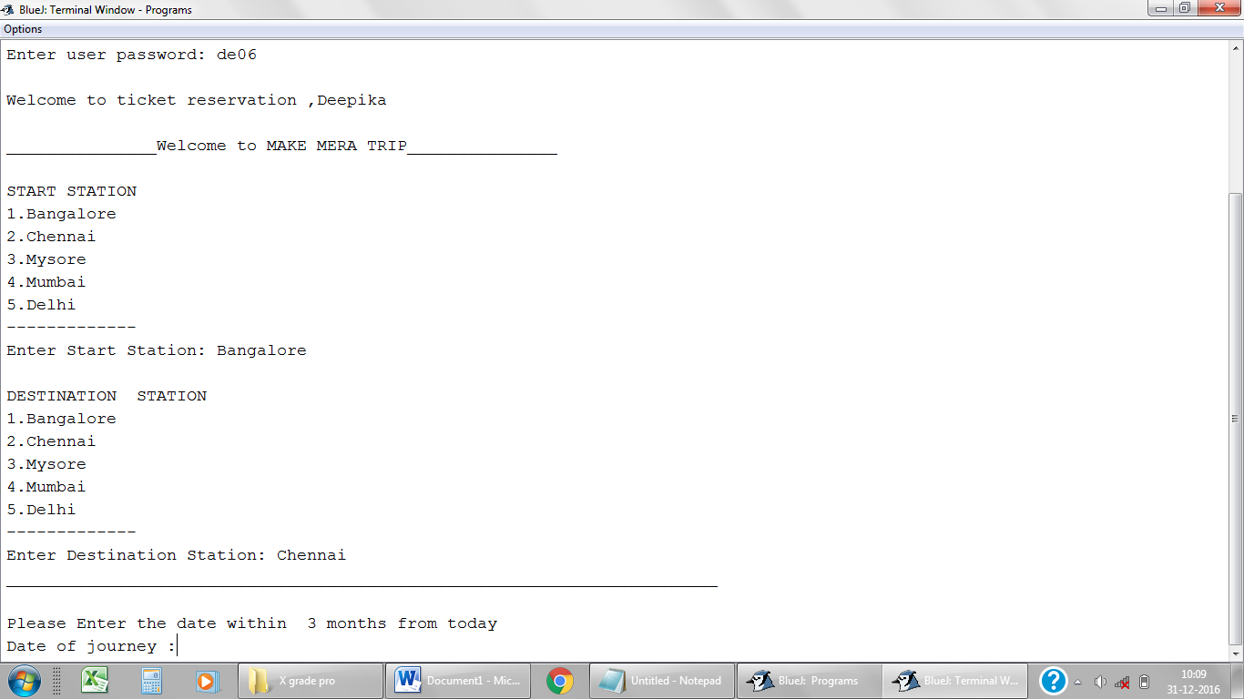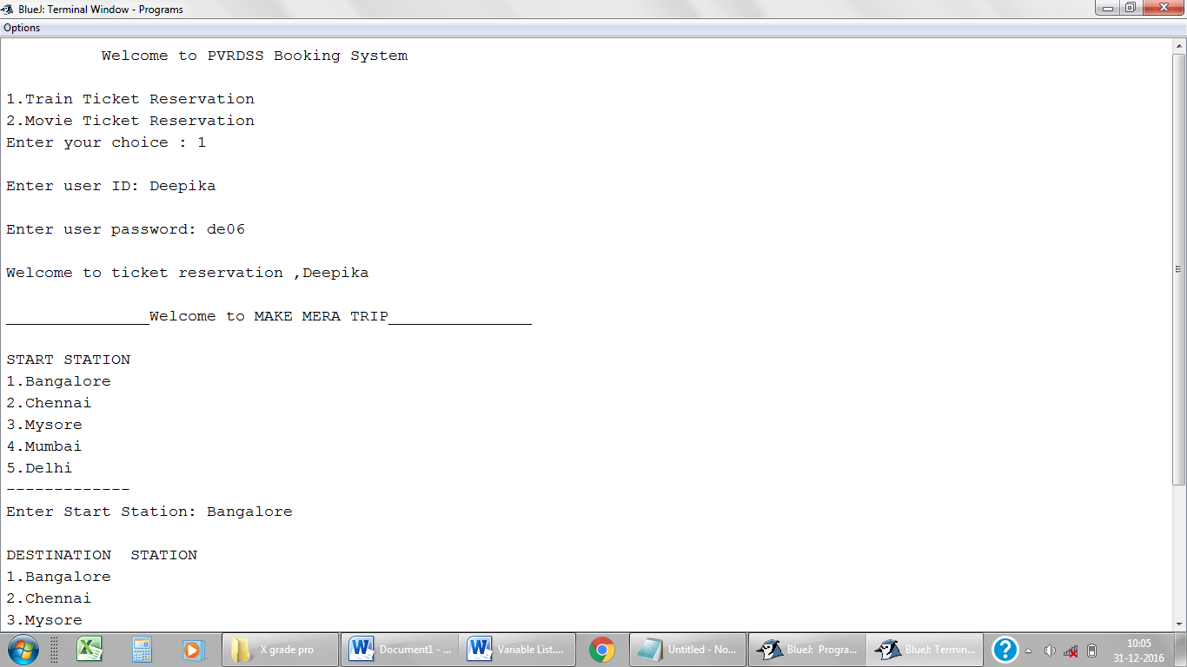

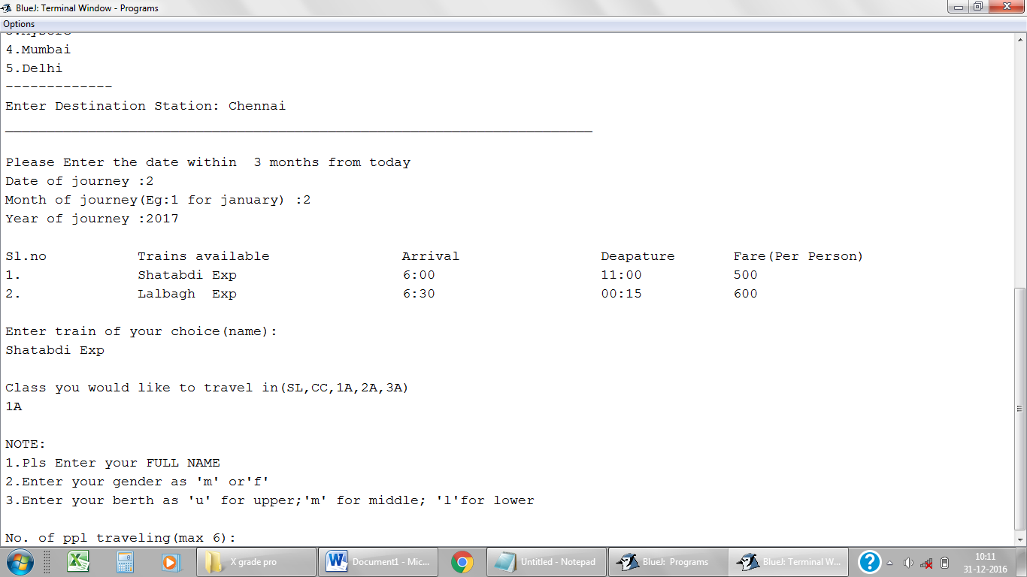

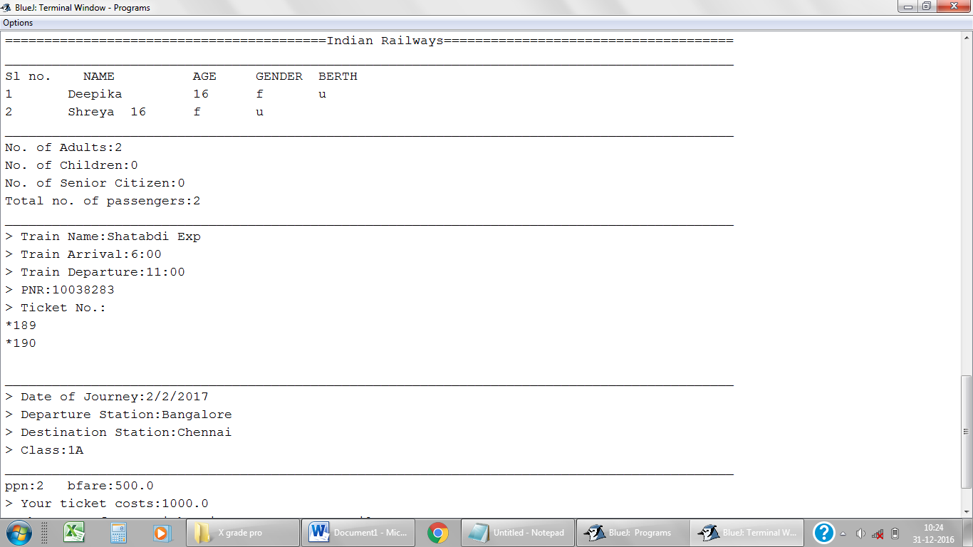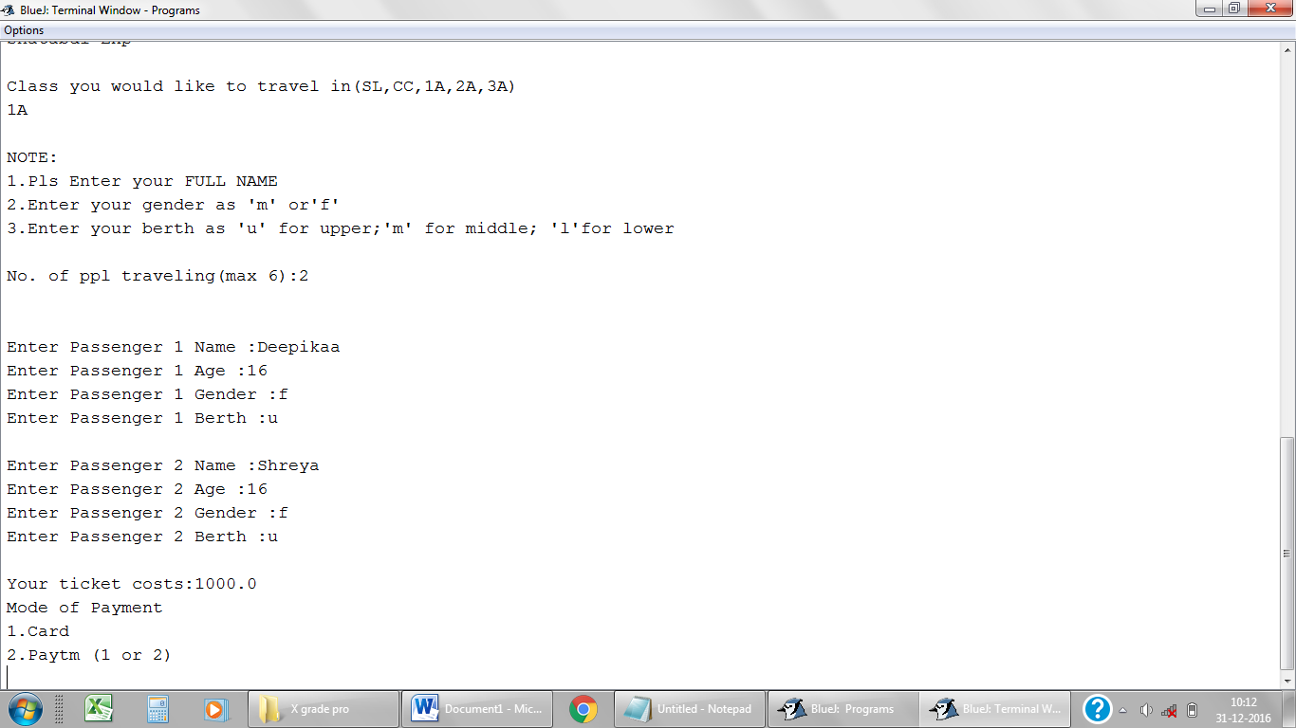

**Paytm**

**Card**

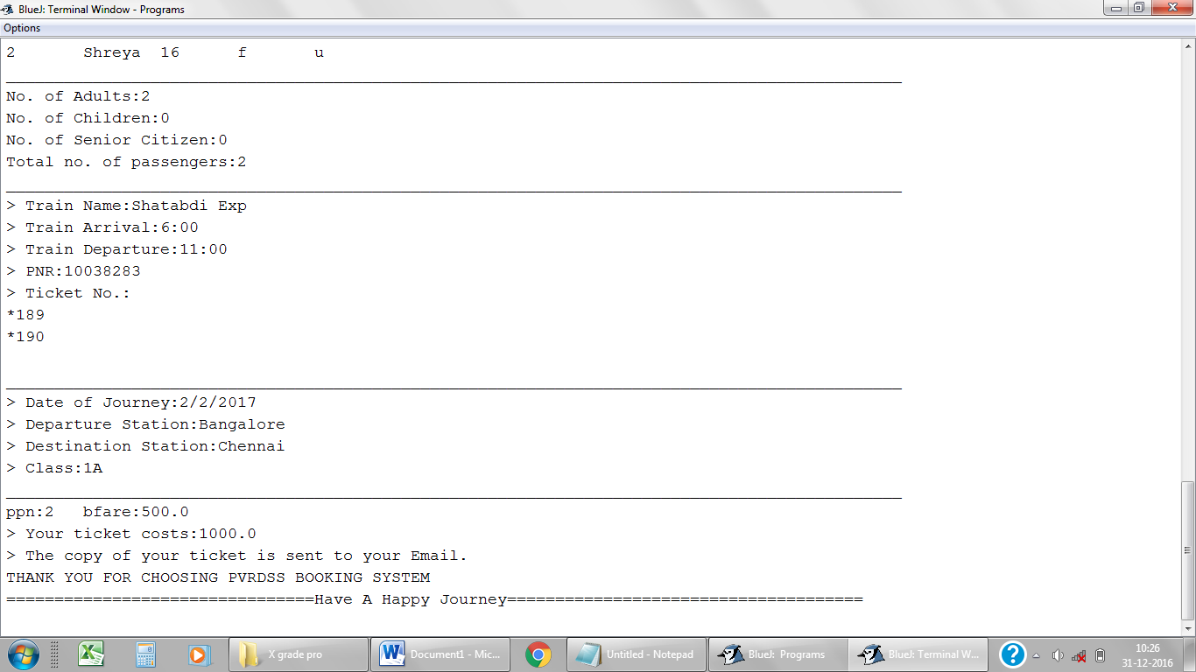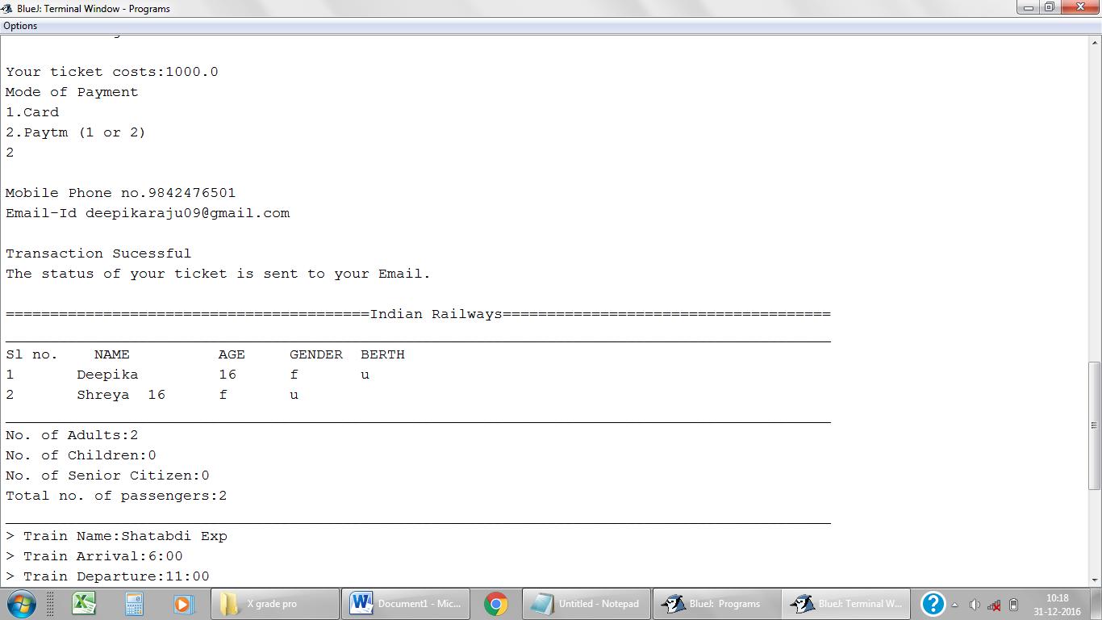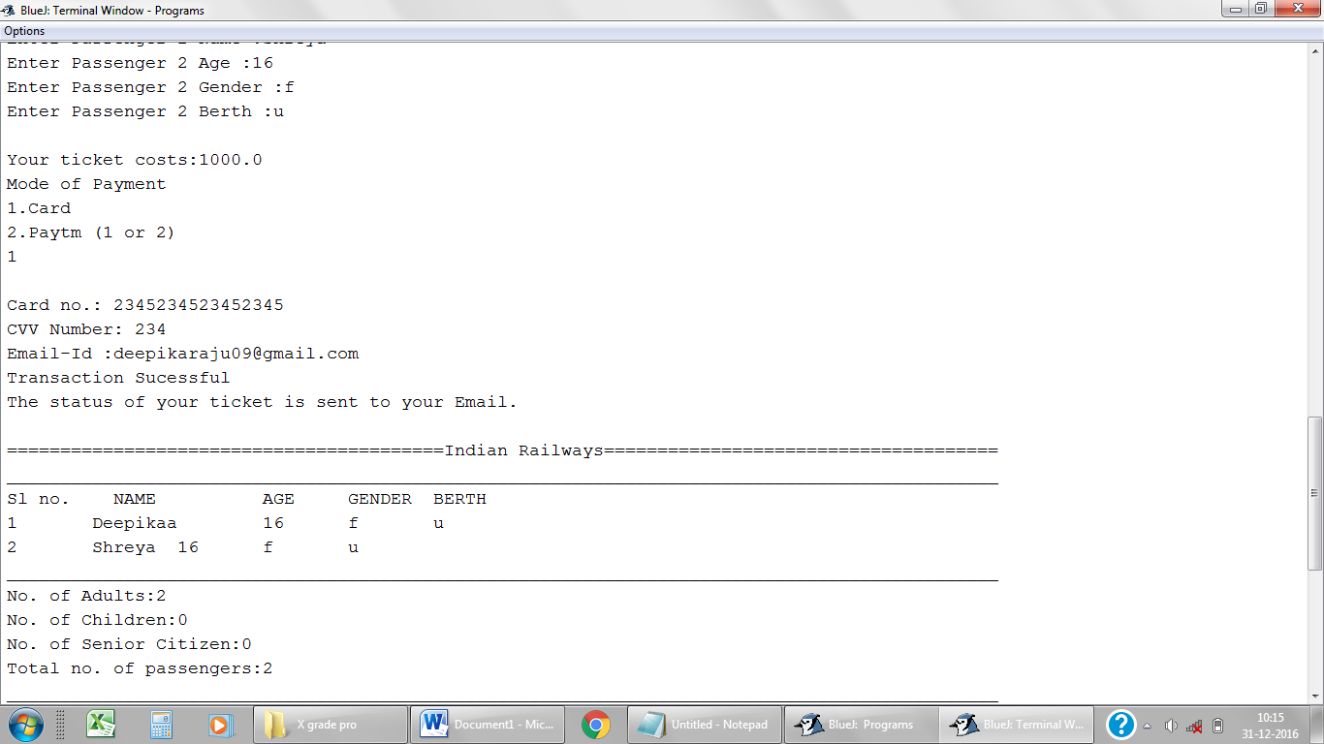

1. **Movie Ticket Reservation**



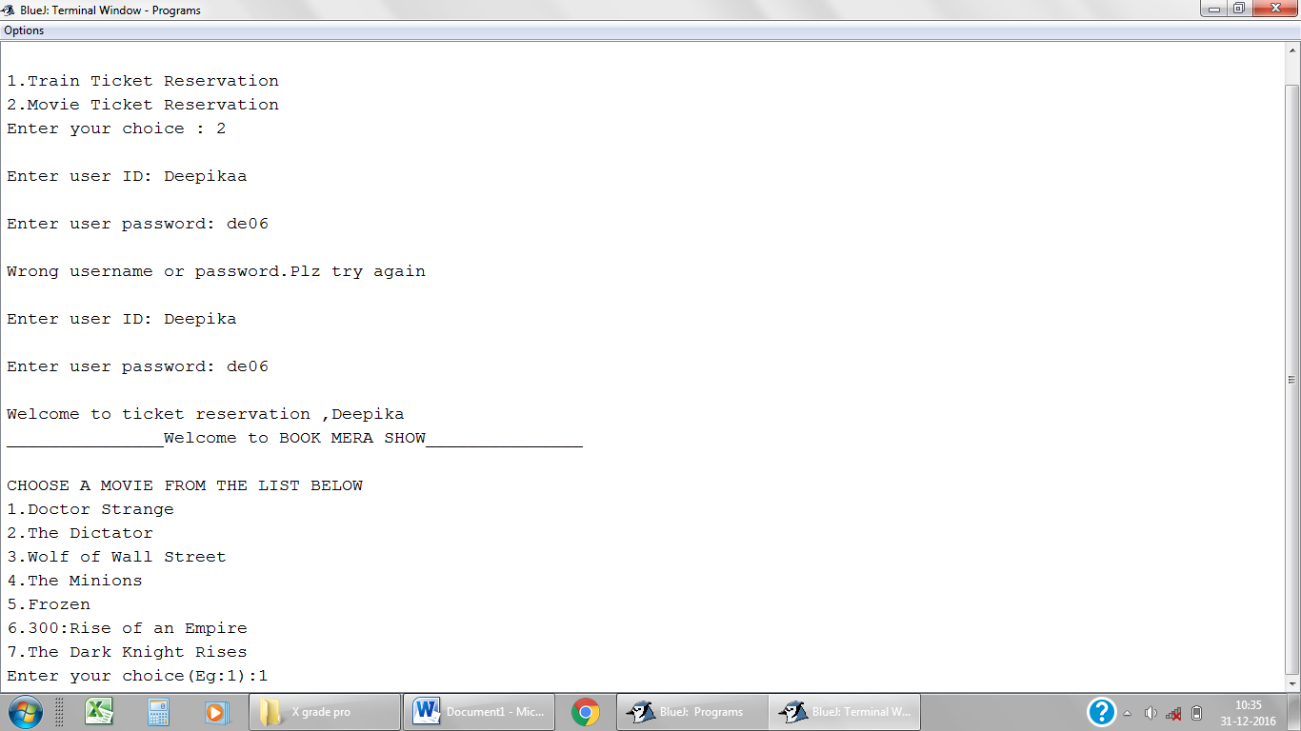

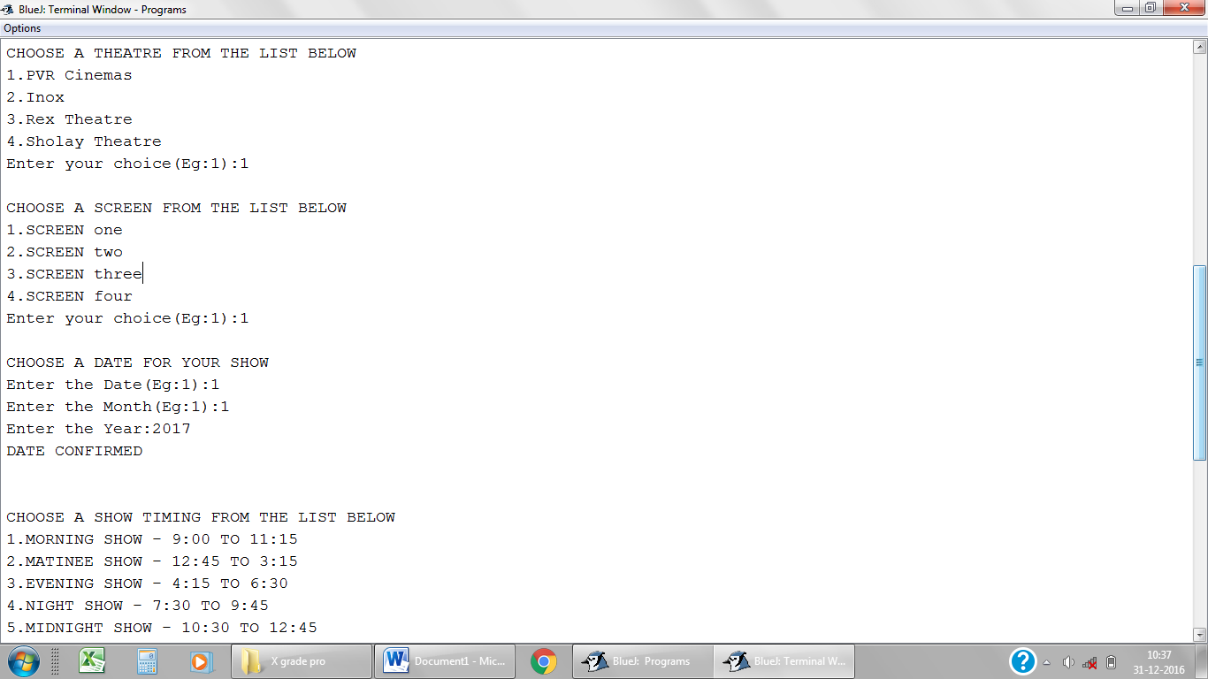

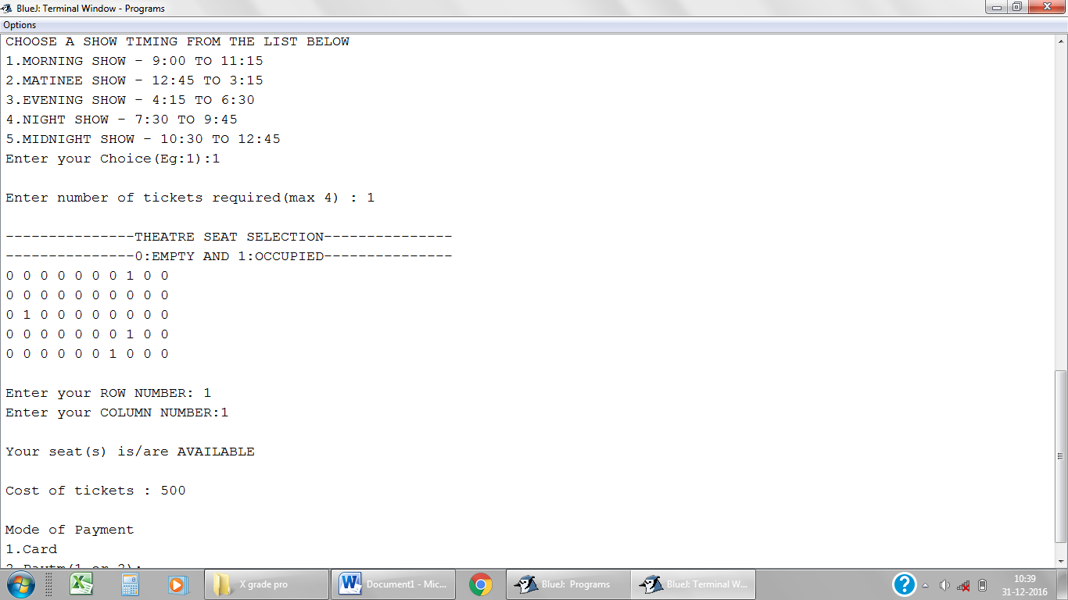



**Paytm**

**Card**

